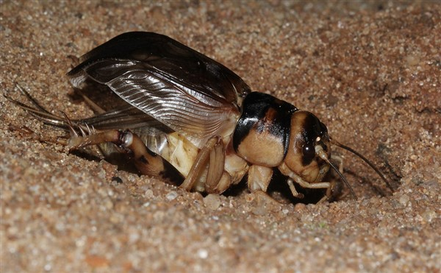https://eaglesrock.com/blog/conservation-journal/an-extraordinary-cricket

